**// Server side C/C++ program to demonstrate Tcp client – server programming .**

#include <unistd.h>

#include <stdio.h>

#include <sys/socket.h>

#include <stdlib.h>

#include <netinet/in.h>

#include <string.h>

#define PORT 8080

int main(int argc, char const *argv[])

{

int server_fd, new_socket, valread;

struct sockaddr_in address;

int opt = 1;

int addrlen = sizeof(address);

char buffer[1024] = {0};

char *hello = "Hello from server";

if ((server_fd = socket(AF_INET, SOCK_STREAM, 0)) == 0)

{

perror("socket failed");

exit(EXIT_FAILURE);

}

if (setsockopt(server_fd, SOL_SOCKET, SO_REUSEADDR | SO_REUSEPORT,&opt, sizeof(opt)))

{

perror("setsockopt");

exit(EXIT_FAILURE);

}

address.sin_family = AF_INET;

address.sin_addr.s_addr = INADDR_ANY;

address.sin_port = htons( PORT );

if (bind(server_fd, (struct sockaddr *)&address, sizeof(address))<0)

{

perror("bind failed");

exit(EXIT_FAILURE);

}

if (listen(server_fd, 3) < 0)

{

perror("listen");

exit(EXIT_FAILURE);

}

if ((new_socket = accept(server_fd, (struct sockaddr *)&address,

(socklen_t*)&addrlen))<0)

{

perror("accept");

exit(EXIT_FAILURE);

}

valread = read( new_socket , buffer, 1024);

printf("%s\n",buffer );

send(new_socket , hello , strlen(hello) , 0 );

printf("Hello message sent\n");

return 0;

}

**// Client side C/C++ program to demonstrate tcp client-server programming**

#include <stdio.h>

#include <sys/socket.h>

#include <arpa/inet.h>

#include <unistd.h>

#include <string.h>

#define PORT 8080

int main(int argc, char const *argv[])

{

int sock = 0, valread;

struct sockaddr_in serv_addr;

char *hello = "Hello from client";

char buffer[1024] = {0};

if ((sock = socket(AF_INET, SOCK_STREAM, 0)) < 0)

{

printf("\n Socket creation error \n");

return -1;

}

serv_addr.sin_family = AF_INET;

serv_addr.sin_port = htons(PORT);

if(inet_pton(AF_INET, "127.0.0.1", &serv_addr.sin_addr)<=0)

{

printf("\nInvalid address/ Address not supported \n");

return -1;

}

if (connect(sock, (struct sockaddr *)&serv_addr, sizeof(serv_addr)) < 0)

{

printf("\nConnection Failed \n");

return -1;

}

send(sock , hello , strlen(hello) , 0 );

printf("Hello message sent\n");

valread = read( sock , buffer, 1024);

printf("%s\n",buffer );

return 0;

}

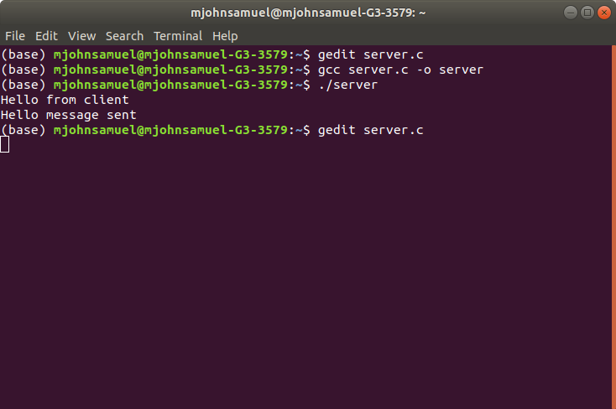

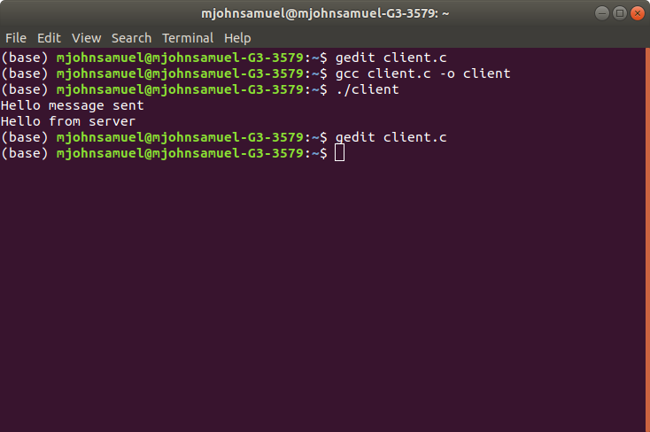

**// Server side implementation of UDP client-server model**

#include <stdio.h>

#include <stdlib.h>

#include <unistd.h>

#include <string.h>

#include <sys/types.h>

#include <sys/socket.h>

#include <arpa/inet.h>

#include <netinet/in.h>

#define PORT 8080

#define MAXLINE 1024

// Driver code

int main() {

int sockfd;

char buffer[MAXLINE];

char *hello = "Hello from server";

struct sockaddr_in servaddr, cliaddr;

// Creating socket file descriptor

if ( (sockfd = socket(AF_INET, SOCK_DGRAM, 0)) < 0 ) {

perror("socket creation failed");

exit(EXIT_FAILURE);

}

memset(&servaddr, 0, sizeof(servaddr));

memset(&cliaddr, 0, sizeof(cliaddr));

// Filling server information

servaddr.sin_family = AF_INET; // IPv4

servaddr.sin_addr.s_addr = INADDR_ANY;

servaddr.sin_port = htons(PORT);

// Bind the socket with the server address

if ( bind(sockfd, (const struct sockaddr *)&servaddr,

sizeof(servaddr)) < 0 )

{

perror("bind failed");

exit(EXIT_FAILURE);

}

int len, n;

len = sizeof(cliaddr); //len is value/resuslt

n = recvfrom(sockfd, (char *)buffer, MAXLINE,

MSG_WAITALL, ( struct sockaddr *) &cliaddr,

&len);

buffer[n] = '\0';

printf("Client : %s\n", buffer);

sendto(sockfd, (const char *)hello, strlen(hello),

MSG_CONFIRM, (const struct sockaddr *) &cliaddr,

len);

printf("Hello message sent.\n");

return 0;

}

**// Client side implementation of UDP client-server model**

#include <stdio.h>

#include <stdlib.h>

#include <unistd.h>

#include <string.h>

#include <sys/types.h>

#include <sys/socket.h>

#include <arpa/inet.h>

#include <netinet/in.h>

#define PORT 8080

#define MAXLINE 1024

// Driver code

int main() {

int sockfd;

char buffer[MAXLINE];

char *hello = "Hello from client";

struct sockaddr_in servaddr;

// Creating socket file descriptor

if ( (sockfd = socket(AF_INET, SOCK_DGRAM, 0)) < 0 ) {

perror("socket creation failed");

exit(EXIT_FAILURE);

}

memset(&servaddr, 0, sizeof(servaddr));

// Filling server information

servaddr.sin_family = AF_INET;

servaddr.sin_port = htons(PORT);

servaddr.sin_addr.s_addr = INADDR_ANY;

int n, len;

sendto(sockfd, (const char *)hello, strlen(hello),

MSG_CONFIRM, (const struct sockaddr *) &servaddr,

sizeof(servaddr));

printf("Hello message sent.\n");

n = recvfrom(sockfd, (char *)buffer, MAXLINE, MSG_WAITALL, (struct sockaddr *) &servaddr, &len);

buffer[n] = '\0';

printf("Server : %s\n", buffer);

close(sockfd);

return 0;

}

